**DAILY ONLINE ACTIVITIES SUMMARY**

|  |  |  |  |  |  |  |  |  |
| --- | --- | --- | --- | --- | --- | --- | --- | --- |
| **Date:** | 06/06/2020 | | | | | **Name:** | CHANDANA S | |
| **Sem & Sec** | 4th SEM ‘A’ SEC | | | | | **USN:** | 4AL18CS016 | |
| **Online Test Summary** | | | | | | | | |
| **Subject** | | Data Communication(18CS46) | | | | | | |
| **Max. Marks** | | 30 | | **Score** | | | 28 | |
| **Certification Course Summary** | | | | | | | | |
| **Course** | Introduction to Neural Networks and Deep Learning | | | | | | | |
| **Certificate Provider** | | | Great Learning | | **Duration** | | | 3.5 Hours |
| **Coding Challenges** | | | | | | | | |
| **Problem Statement:**1. Write a Java Program to find the duplicate characters in a string.  2. Write a program in C to rotate an array by N positions. | | | | | | | | |
| **Status:** Completed | | | | | | | | |
| **Uploaded the report in Github** | | | | | YES | | | |
| **If yes Repository name** | | | | | <https://github.com/chandushivalingareddy/lockdown-coding> | | | |
| **Uploaded the report in slack** | | | | | YES | | | |

**Online Test Details:**

The online test was from module 5 which was about Wired LANs Ethernet, Wireless LANs, Other wireless Networks. There were 30 questions of 1 mark each which lasted for 45 minutes. The questions were easy. I scored 28 out of 30.

**Snapshot**:

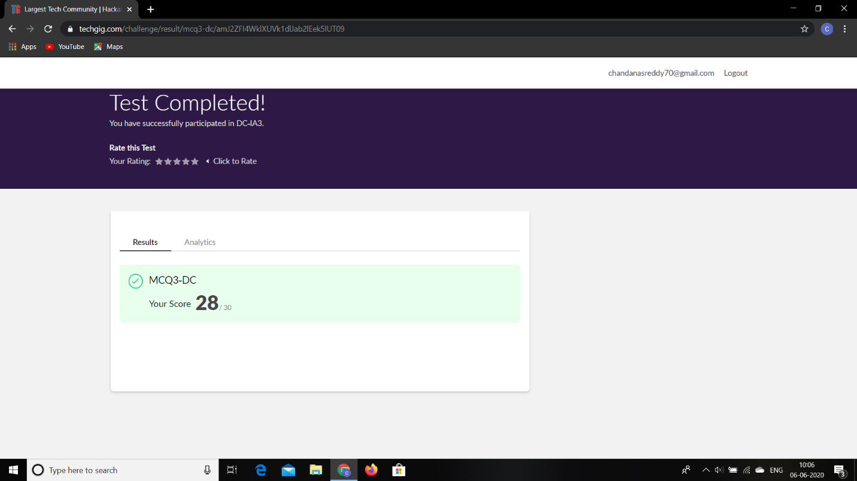

**Certification Course Details:**

**Name of the course**: Introduction to Neural Networks and Deep Learning

**Certificate Provider**: Great Learning

Today I went through the course that explained about Building Blocks of Neural Networks.

**Snapshot:**

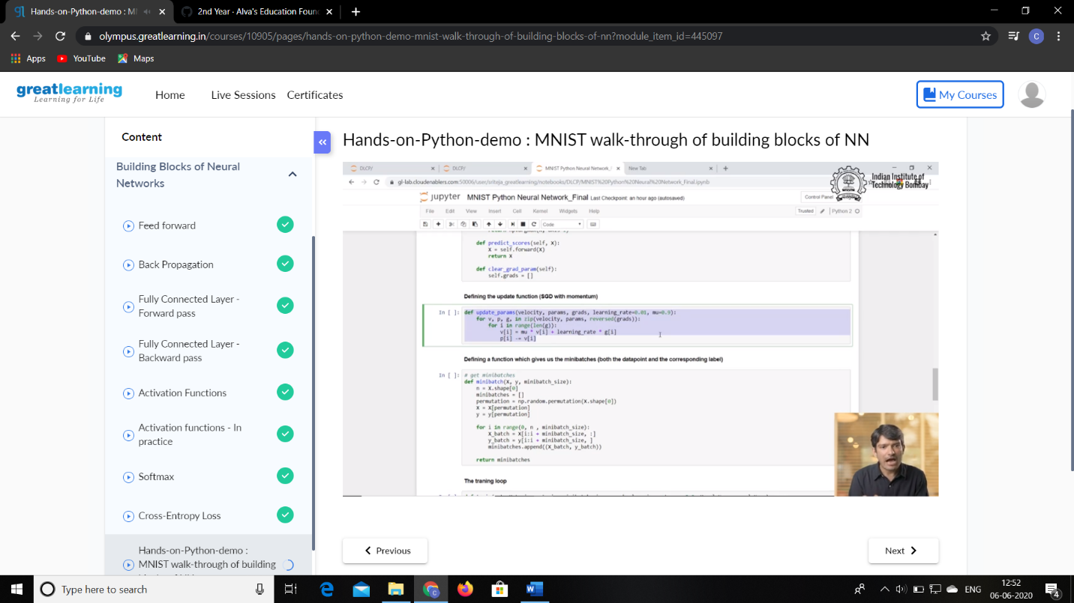

**Online Coding Details:**

Problem 1: Write a Java Program to find the duplicate characters in a string.

Output: Process being scheduled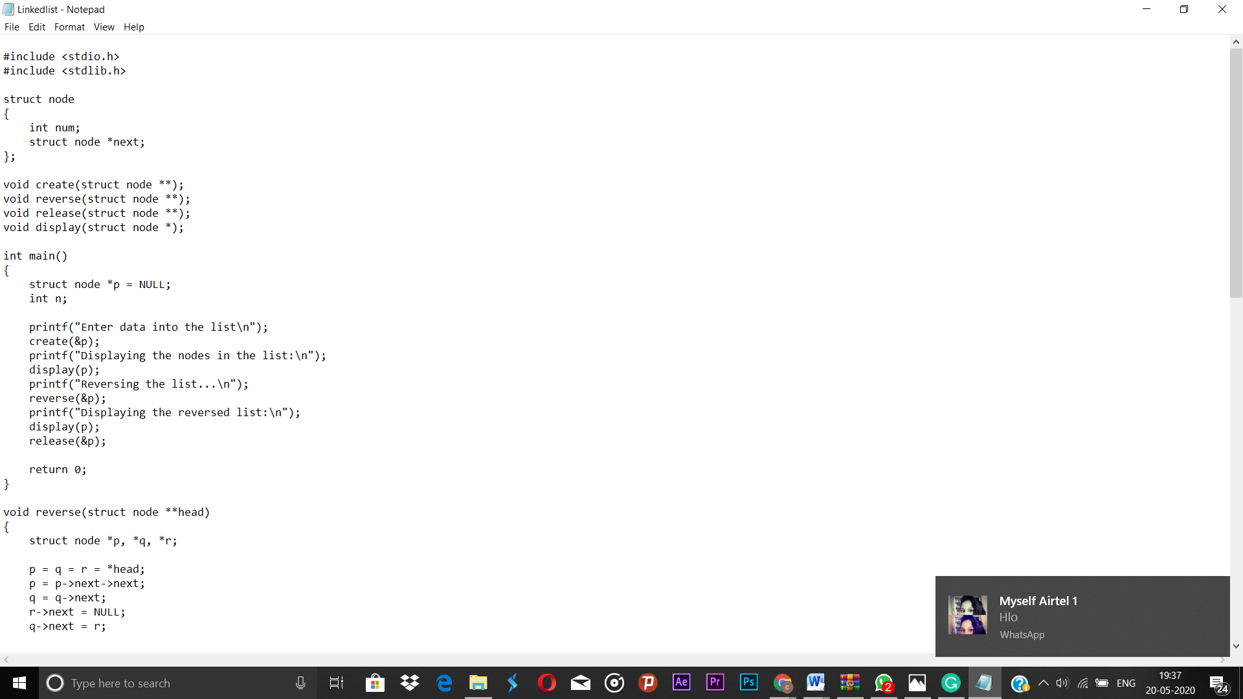Top of Form

Bottom of Form

**Snapshot:**

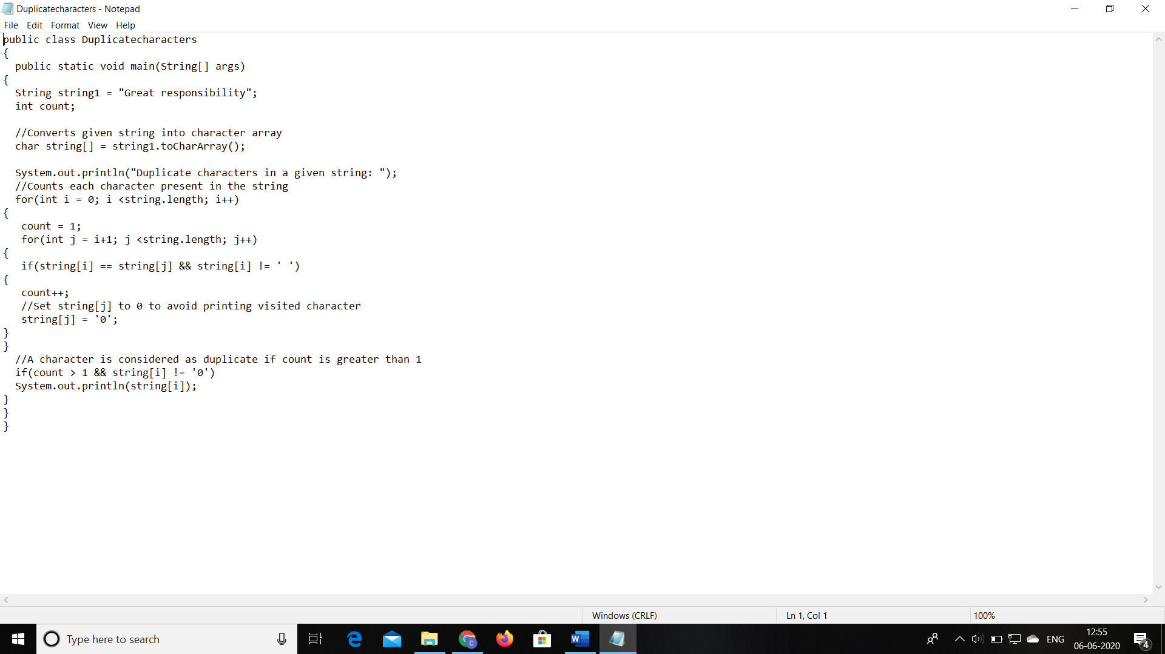

Problem 2: Write a program in C to rotate an array by N positions.

**Snapshot:**

